Contents

1 Overview 3

2 Preparations 3

2.1 Prerequisites 3

2.2 Deployment Process 3

3 Configuring Symantec Management Console 8.1 4

Monitoring Huawei Servers by Using Symantec Management Console 8.1

**Keywords: monitoring, SNMP, trap**

**Abstract: This document describes how to use Symantec Management Console 8.1 to monitor Huawei servers.**

**Acronyms and Abbreviations: The following table lists acronyms and abbreviations used in this document.**

|  |  |
| --- | --- |
| Acronym and Abbreviation | Full Spelling |
|  |  |
|  |  |
|  |  |
|  |  |

# Overview

This document describes how to use Symantec Management Console 8.1 to monitor Huawei servers through SNMP.

# Preparations

## Prerequisites

Test network diagram



IP address configuration:

Symantec Management Console IP address: 192.168.2.223 255.255.0.0

E9000 iBMC IP address: 192.168.12.10 255.255.0.0

E9000 HMM IP address: 192.168.10.1 255.255.0.0

## Deployment Process

The steps are as follows:

Install and deploy Symantec Management Console 8.1.

Set the network of Symantec Management Console 8.1.

----End

**Installing and Deploying Symantec Management Console 8.1**

Deploy Symantec Management Console 8.1 on the Windows Server 2012 OS.

You can download the software of the trial version from the official website.

Official website: https://www.symantec.com/products/server-management-suite

The software installation is friendly. During the installation process, dependent software that is lacked in the environment will be checked. You can download and install the dependent software as prompted.

After the installation is complete, you need to set the database and management account. You can use the domain account.

After the installation is complete, run Symantec Management Console 8.1 to start the management.

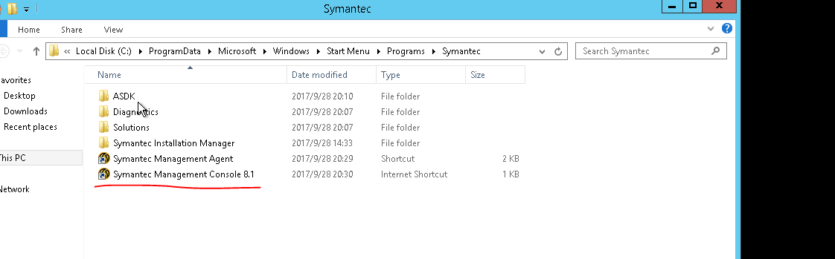

# Configuring Symantec Management Console 8.1

The configuration steps are as follows:

Set the SNMP credential.

Import the SNMP MIB file.

Modify the imported SNMP information.

Set the SNMP trap information of the server.

----End

**Setting the SNMP Credential**

On the home page, choose **首次设置** > **搜索计算机**, as shown in the following figure.

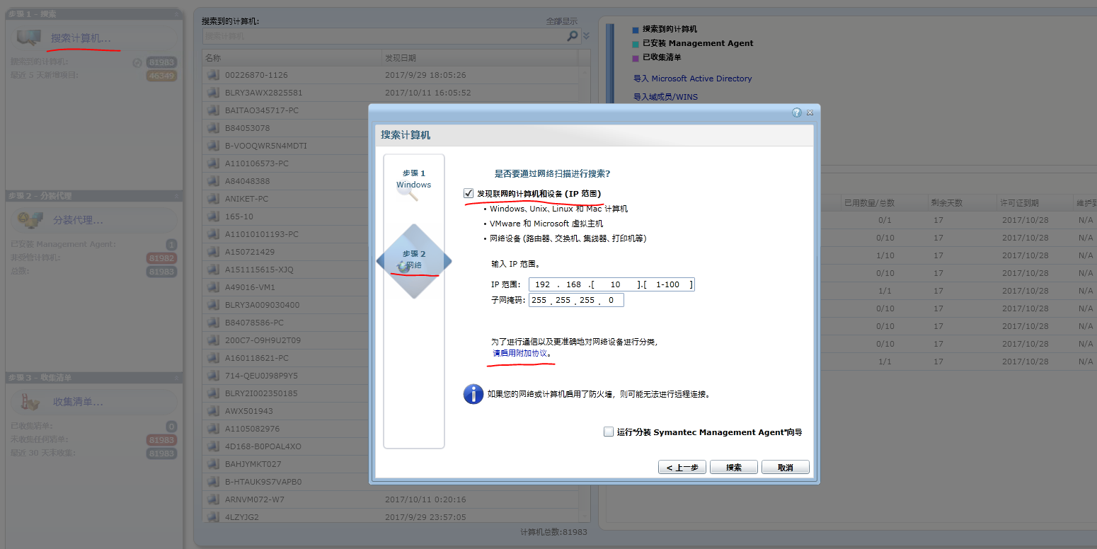

Click the button for configuring an additional protocol and configure SNMP. Enable only **SNMP V1 V2**, and set the SNMP community name, as shown in the following figure.

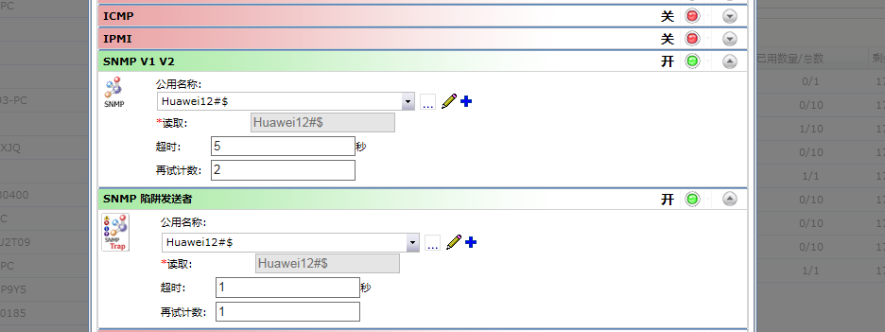

**Importing the SNMP MIB File**

Click the **设置** tab to expand all nodes in the navigation tree, find **SNMP MIB导入浏览器**, select the MIB file, and click **导入**.

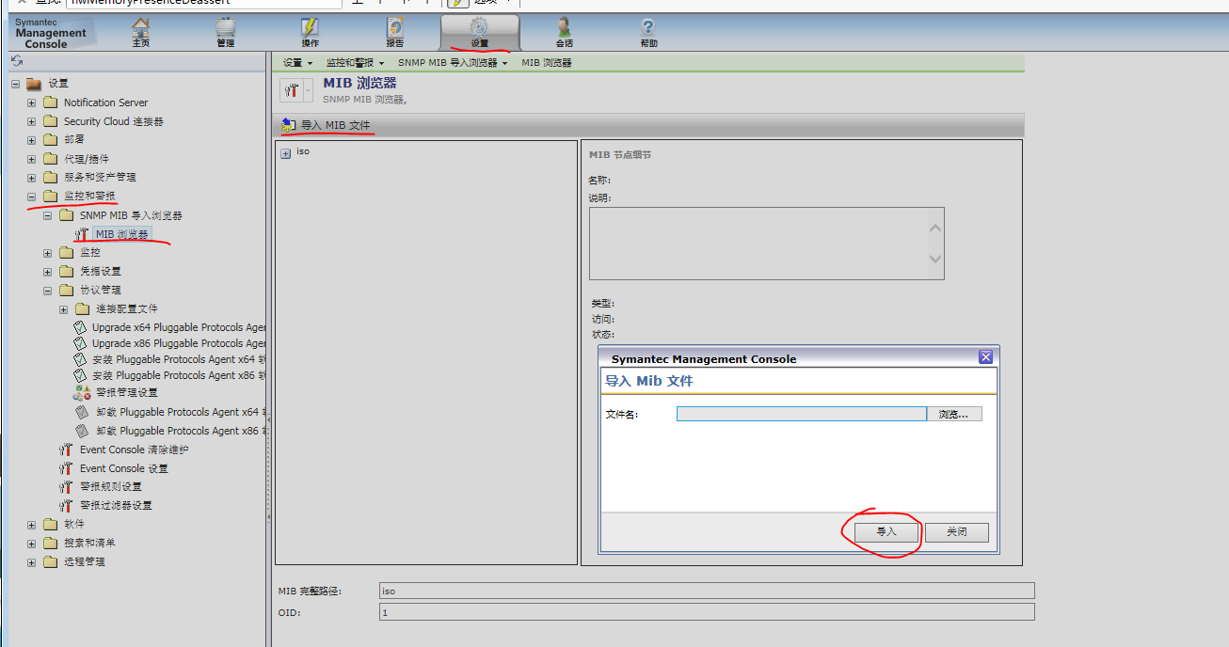

**Modifying the Imported SNMP Information**

In **警报管理设置**, modify the imported SNMP information.

Modify the alarm category, as shown in the following figure.

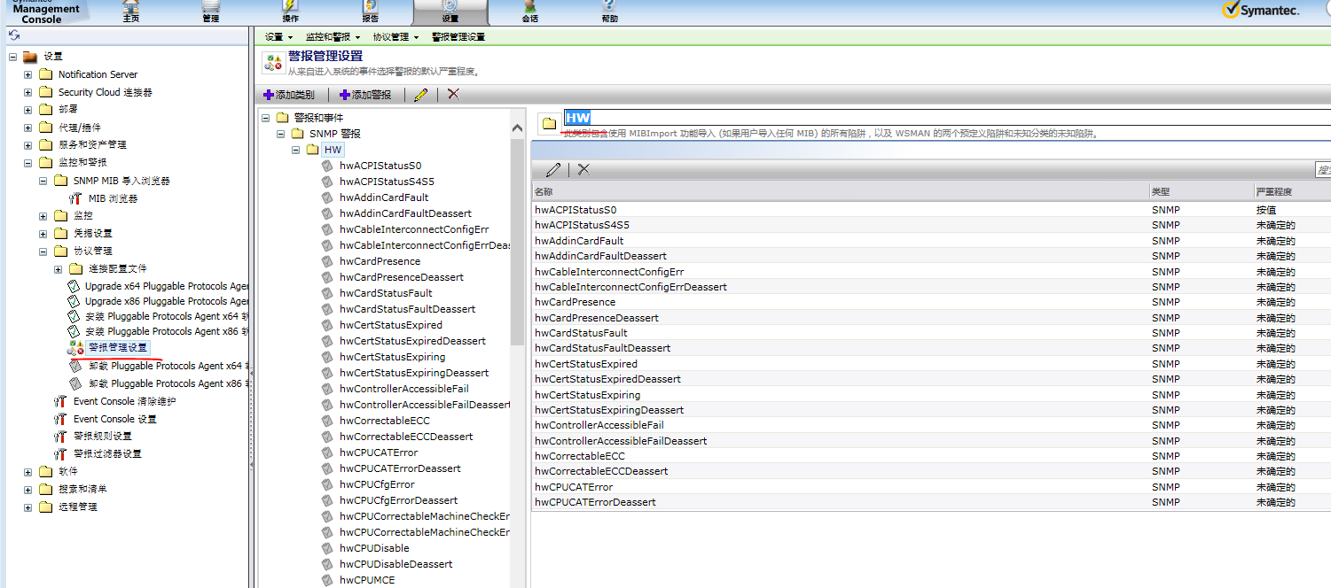

Define the alarm severity, as shown in the following figure.

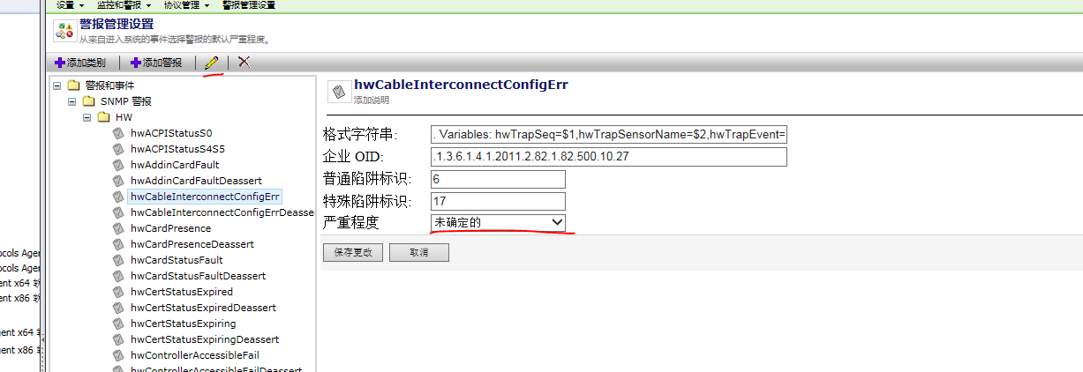

**Setting the SNMP Trap Information of the E9000 Server**

HMM configuration

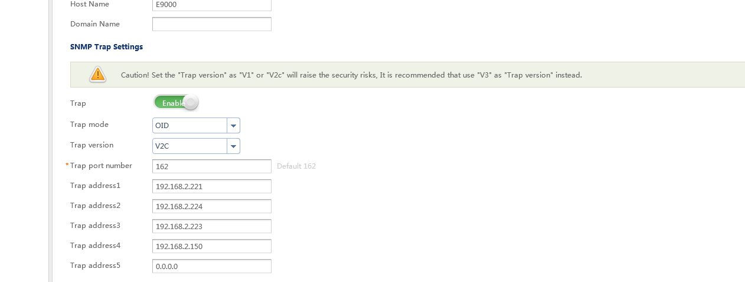

iBMC configuration

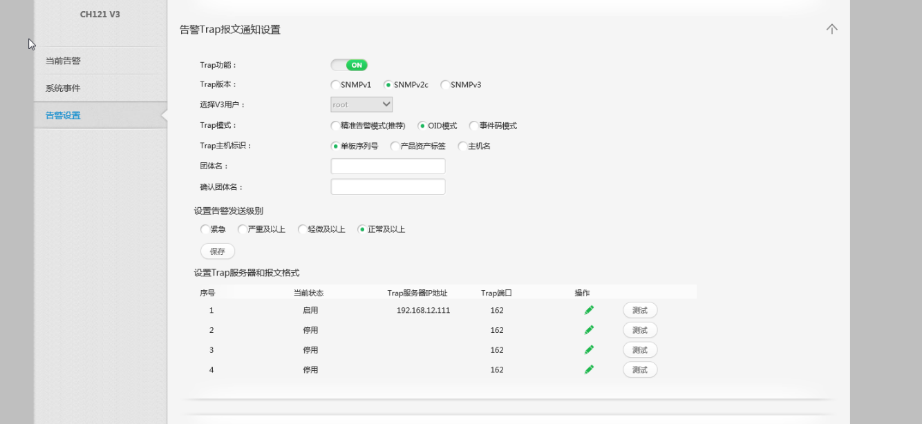

After the configuration is complete, click **监控与告警** on the home page to view the server status alarm information.

